

SUPERIOR UNIVERSITY LAHORE
GOLD CAMPUS

NAME: MUHAMMAD MOIZ RAZA
ROLL NO: SU92-BSAIM-F24-061
PROGRAM: ARTIFICIAL INTELLIGENCE
SEMESTER: 4th SEMESTER
SECTION: BSAI-4A
SUBJECT: PROGRAMMING OF AI (LAB)

Submission Title: LAB TASK 9
Submitted To: Sir Rasikh Ali

TITLE: Information Extraction Named Entity Recognition (NER), NLTK, Relationship Extraction, Word Sense Disambiguation (WSD)

Overview
This task is a simple Natural Language Processing (NLP) system that helps a computer understand human language. It uses Word Sense Disambiguation (WSD), which means finding the correct meaning of a word based on the sentence context. The program checks surrounding words and matches them with predefined meanings to make the right decision.

Purpose
The purpose of this task is to remove confusion in words that have multiple meanings and help computers understand text more clearly and accurately.

Why We Use It
We use this because computers cannot understand language like humans. This task helps them use context to choose the correct meaning of words and improve accuracy.

Real-Life Usage
It is used in search engines, chatbots, and voice assistants. For example, it helps decide whether “bank” means a financial place or a river side depending on the sentence.

SCREENSHOT
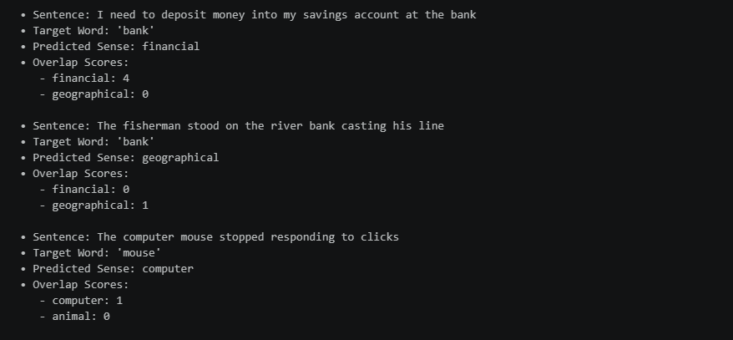

THE END

